FINAL PROJECT REPORT
GHAMGHUSAR – A MENTAL WELLBEING MOBILE APP



Project Supervisor MS. ARFA SIKANDAR

Submitted By
FYP 19CS-005

FATIMA Comp.Sc-19015

DEPARTMENT OF COMPUTER SCIENCE
GC WOMEN UNIVERSITY, SIALKOT

CERTIFICATE

This is to certify that Fatima; Comp.Sc-19015 have worked on and completed their Software Project at Department of Computer Science, GC Women University, Sialkot in partial fulfillment of the requirement for the degree of BS in Computer Sciences under my guidance and supervision.

Supervisor / Internal Examiner

Ms Arfa Skandar Supervisor,
Department of Computer Science GC Women University, Sialkot

(Signature)

In our opinion, it is Satisfactory, up to the mark, and therefore fulfils the requirements of BS honors in Computer Science.

External Examiner/Subject Specialist
Evaluator 1 |  | Evaluator 2 |  | Evaluator 3
(Signature) |  | (Signature) |  | (Signature)  Accepted By:
 |  |  |  | (For office use)

DEDICATION

I want to dedicate my work to myself, my parents and my respected teachers Ms. Arbab Arif, Ms. Farzana Anjum, Ms. Sadia Azam for polishing me and helping me to be the best version of myself. Ms. Arfa Sikandar, Due to their guidance and encouragement I am able to completethis project. I’m really thankful to them for providing me the opportunity to prove and improve myself in a meaningful direction and for giving me the courage and determination to complete this project. All praises and Thanks To ALLAH ALMIGHTY for their Blessing towards me.

ACKNOWLEDGEMENT

All Praises to ALLAH Almighty who gave strength and knowledge to complete this project. The Completion and Success of this project required a lot of research, guidance, and support from experts. We are much thankful to all our teachers and mentors who guided us throughout this project. Thanks to Stack overflow and youtubers who upload content for us. A special thanks to founders of chatGPT. I’m grateful to Ms Arfa Sikandar, for providing us an opportunity to do the project work on “Ghamghusar – A mental well-being mobile app”, to Ms. Mariam and Ms. Ayesha Asghar, Incharges of psycho-social well-being Centre at GCWUS for their guidance and helping me collect data and resources for my project, that made me complete the project duly. I’m extremely thankful to all of them for providing such a nice support and guidance, although they had busy schedule managing the corporate affairs. I am much thankful to whole faculty of Department of Computer Science who was always available to assist us and taught us much well to complete our graduation. Completion of this project was impossible without support and prayers of my sisters and my friends who have been always there for emotional and moral support.

TABLE OF CONTENTS

- Gathering and Analyzing Information 2
  - Introduction: 2
  - Purpose: 2
  - Product Scope: 2
  - Definition Acronym and Abbreviations: 2
  - Supplementary requirements: 3
    - Usability 3
    - Reliability 3
    - Supportability 3
1.6. Key Stake holders 5
- Planning the Project 6
  - Introduction 6
    - Product 6
    - Scope… 6
    - Goals 6
    - Business Goals… 7
    - Document Conventions 7
  - Overall description 8
    - Product features 8
    - User classes& characterstics 9
    - Opening Environment 9
    - Design & implementation Constraints 9
    - Assumptions & dependencies 10
  - Functional Requirements 10
    - Use cases and user scenarios. 11
  - Other Non-functional requirements 16
2.2.1 Performance Requirements. 16
2.2.1 Safety Requirements… 16
2.2.1 Security Requirements 16
2.2.1 Software quality attributes. 16
  - Other Requirements 17
  - Software lifecycle model 17
  - Work Plan 20
    - Phases description of start and end of module 20
    - Project Structure 20
    - Team Structure 20
    - Project Schedule 21
- Designing the project 23
  - Architecture Design Diagram 23
  - Sequence Diagrams 23
    - Signup/Register regular user 23
    - Login 24
    - Disorder assessment 24
    - Daily task/Planner 25
    - Additional Courses 25
    - Program switching 26
    - Chat regular user 26
    - Chat therapist end… 26
    - Logout 27
    - Psychologist assessment 27
    - Document approval/ interview… 27
  - Class Diagram 28
  - Database Diagram 28
  - Design of Ghamghusar 29
- Development 34
  - Development Plan architecture 34
  - Test Cases 35
    - Registration… 35
    - Register as psychologist 35
    - Login… 36
    - Edit profile… 37
    - Privacy Policy… 37
    - Assessment 38
    - Planner 38
    - Add additional course 39
    - Assess additonal course 39
    - Add new program 39
    - Switch between programs… 39
    - Chat with therapist 39
    - Submit a report 40
    - Give test 40
    - Approve disapprove request 41
    - Manage report 41
    - Give test 41
- Conclusion and Future Work: 44
  - Conclusion 44
  - Future work 44
REFERENCES 46
APPENDIX 47

LIST OF TABLES

Table 1. Defination and Acronym 3
Table 2. Usage Scenario for regular user 11
Table 3. Usage Scenario for psychologist 13
Table 4. Usage Scenario for admin 14
Table 5. Work plan of GhamGhusar 20
Table 6. Team Structure 20
Table 7. Gantt Chart first 4 months of the development process 21
Table 8. Gantt chart of last 4 months of the development process 21

LIST OF FIGURES

Figure 1. Use case diagram of Regular user 11
Figure 2. Use case diagram of psychologist end 13
Figure 3. Waterfall model visual representation 18
Figure 4. Architecture Design Diagram 23
Figure 5. Regular user signup 23
Figure 6. Sequence diagram Login 24
Figure 7. Sequence diagram Assessment… 24
Figure 8. Sequence diagram PlannerDaily Task 25
Figure 9. Sequence diagram Additional courses 25
Figure 10. Sequence diagram program swithching 26
Figure 11. Sequence diagram chatting with therapist 26
Figure 12. Sequence diagram chat by therapist 26
Figure 13. Logout 27
Figure 14. Psychologist Assessment 27
Figure 15. Document Aproval/Interview meeting 27
Figure 16. Class diagram 28
Figure 17. Database diagram 28
Figure 18. Psychologist End 29
Figure 19. Psychologist signup 29
Figure 20. Psychologist before assessment 29
Figure 21. Psychologist assessment 29
Figure 22. Psychologist assessment result 29
Figure 23. Psychologist personal and academic information 29
Figure 24. Psychologist Waiting page 30
Figure 25. Psychologist home 30
Figure 26. Psychologist chats/requests 30
Figure 27. Psychologist chatbox 30
Figure 28. Regular user landing page 30
Figure 29. Signup 30
Figure 30. Login 30
Figure 31. Pick a mental health goal 31
Figure 32. Load assessment 31
Figure 33. Disorder assessment 31
Figure 34. Results 31
Figure 35. Regular user home 31
Figure 36. Planner activities 31
Figure 37. Chats 31
Figure 38. Switch courses 32
Figure 39. Edit profile 32
Figure 40. Policy 32
Figure 41. Admin home 32
Figure 42. Pending appications 32
Figure 43. Application details 32
Figure 44. Develeopment plan architecture 32

Summary
The increasing rates of mental health issues, particularly among adolescents and young adults, and the lack of easily accessible counseling services are observed in Pakistan and globally[1]. The solution involves using technology for health and symptom assessments to generate self care planners for users and suggesting psychologists based on gender. Gham Ghusar is an android application aimed at addressing the growing mental health problems faced by individuals. The app offers a comprehensive mental health platform that provides self-care, therapy sessions, psychiatric care, and more. The app detects the 10 most common mental health problems and offers foundation treatment courses for them. Users are asked specific questions to assess their symptoms, and based on the results, the app suggests personalized healthy activities and exercises. Additionally, the app allows psychologists to create profiles and offer their services to users. Overall, Gham Ghusar aims to be a digital powerhouse of mental health resources.

Page left blank intentionally

CHAPTER 1
Gathering & Analyzing Information

© Project Management Office Revised Version 5.0
Department of Computer Science, GC Women University Sialkot.
1

1 Gathering and Analyzing Information

Introduction:

Gham Ghusar is an android application, the mental health platform where you can access everything you may need for your mental health - self-care, therapy sessions, psychiatric care and much more. The main objective of this application is to provide foundation treatment courses for 12 most common mental health problems after detection using cognitive AI. The application will ask users questions that are used in global symptom assessments of these mental health problems, calculate their score, and then will suggest them some healthy activities and exercises according to their problem to keep their mental health at a good place. People can also sign up as psychologists and create their profile like fiverr (See Appendix A). Users will be able to communicate to the psychologist via texting or calling. In short, Gham Ghusar is a digital powerhouse of mental health resources.

Purpose:

    - The purpose of the project is to make mental health easily accessible for everyone.

    - The project aims to create a digital ecosystem of all mental health resources.

    - In this document, we will be covering all the required constraints, diagrams, and use cases that are required to understand how the project has been implemented.

Product Scope:

The target audience of Gham Ghusar is Pakistani Youth (12-40 years of age), Psychologists, and psychiatrists. Hence it targets a large audience in terms of its users It will be providing mental health services, detection, and treatment of mental health problems. Moreover, it will be bringing learning opportunities, clinical and behavioral psychologists, and psychiatrists who usually work in hospitals, academic institutions, counselling, and rehabilitation centers, will be able to provide their services nationwide, using Gham Ghusar. This app will be Accessible online.

Definition Acronym and Abbreviations:

This document uses the following conventions.
Table 1.Defination and Acronym

DB | Database
GHAMGHUSAR | Name of our product(web)
Rid_0x | Assigned id for features
UC | Use Cases
Disorder assessments | Assessments used for mental health disorders,

including depression, are standardized tools designed to gather information and measure specific aspects of an individual's symptoms, experiences, and functioning. These assessments aim to provide a structured and reliable way to
evaluate and diagnose mental health conditions.
Foundation Treatment courses | Treatment courses, created by psychologists or mental health professionals, are individualized plans designed to address the specific needs of a person diagnosed with a mental health disorder. These courses typically consist of therapeutic interventions, activities, and strategies aimed at alleviating symptoms, improving functioning, and  promoting overall well-being.
Cognitive AI system | A cognitive computer or system  - Learn at scale.  - Reasons with purpose.  - Interacts with human naturally.  - Rather than explicitly programmed these systems take decision from their interaction with humans and their experiences with their environment.

Supplementary requirements:
    - Usability: while the developing process, we have considered all the five E’s to must be present in our project. By five E’s, we mean Efficiency, Engaging product, Effectivity, Error tolerance, and Ease to learn. We use a clear and simple method to respond to the user using minimum resources. Its features are interesting which urge people to have a visit to this website.
    - Reliability: To ensure reliability in my mental health app, I focused on thorough testing to identify and fix any issues. I conducted extensive testing at each development stage, including functionality, stress, and compatibility testing. This helped me ensure that the app performs consistently across different devices. Additionally, I actively sought user feedback to promptly address any concerns and provide a reliable user experience.
    - Supportability: a member of our team will always be available for any technical support in case of need. Therefore, users can always reach the technical experts to get rid of their problems. This support team may enlarge in future.

Key Stakeholders

Admin: The admin is responsible for managing and overseeing the overall functioning of the app, including user accounts, content moderation, and system settings.

Psychologist: The psychologist plays a role in providing professional guidance, support, and advice to app users, utilizing their expertise in psychology to assist users with mental health issues and concerns.

Regular user: Regular users are the individuals who utilize the app's features and services for their personal needs, such as accessing resources, or seeking assistance from professionals within the app.

CHAPTER 2
Software Requirement Specification

© Project Management Office Revised Version 5.0
Department of Computer Science, GC Women University Sialkot.
5

2 Software Requirement specification

  - Introduction:
Gham Ghusar is an android application, the mental health platform where you can access everything you may need for your mental health - self-care, therapy sessions, psychiatric care and much more. The main objective of this application is to provide foundation treatment courses for 12 most common mental health problems after detection using cognitive AI. The application will ask users questions that are used in global symptom assessments of these mental health problems, calculate their score, and then will suggest them some healthy activities and exercises according to their problem to keep their mental health at a good place. People can also sign up as psychologists and create their profile like fiverr (See Appendix A). Users will be able to communicate to the psychologist via texting or calling. In short, Gham Ghusar is a digital powerhouse of mental health resources.

Product

Introducing Gham Ghusar, the ultimate Android application for mental health. Access self-care, therapy, and psychiatric care, along with AI-driven treatment courses for common mental health problems. Through cognitive AI, Gham Ghusar detects issues, calculates scores, and offers personalized activities and exercises. Connect with licensed psychologists, create profiles, and engage in meaningful communication. With a comprehensive range of resources, Gham Ghusar empowers individuals to stabilize their mental health, enhance productivity, self-image, and relationships. Take charge of your well-being with Gham Ghusar, the digital solution for a healthier mind and a happier life.

Scope

The target audience of Gham Ghusar is Pakistani Youth (12-40 years of age), Psychologists, and psychiatrists. Hence it targets a large audience in terms of its users It will be providing mental health services, detection, and treatment of mental health problems. Moreover, it will be bringing learning opportunities, clinical and behavioral psychologists, and psychiatrists who usually work in hospitals, academic institutions, counselling, and rehabilitation centers, will be able to provide their services nationwide, using Gham Ghusar. This app will be Accessible online.

Goals

Our goal is to:

- Develop a user-friendly Android application for mental health support.
- Implement cognitive AI algorithms to detect and assess common mental health problems.
- Provide personalized treatment courses based on individual symptoms and needs.
- Enable seamless communication between users and licensed psychologists.
- Offer a range of self-care resources, exercises, and activities to promote positive mental health.

Business Goals

Our product is a mental well-being mobile application so it as following business goals.

- Market Leadership: Establish Gham Ghusar as a leading mental health app, gaining a significant market share by providing comprehensive and user-centric mental health solutions. Aim to be recognized as the go-to platform for individuals seeking self-care resources, therapy, and psychiatric care.
- User Acquisition and Retention: Acquire a large user base by implementing effective marketing strategies, user-friendly features, and personalized experiences. Focus on user retention through continuous improvements, tailored content, and engaging interactions, fostering long-term engagement and loyalty.
- Collaboration with Mental Health Professionals: Forge strategic partnerships with licensed psychologists and mental health professionals to offer high-quality therapy and psychiatric care services through the platform. Establish a strong network of professionals, ensuring a diverse range of expertise and meeting the specific needs of users.
- Monetization and Revenue Generation: Implement monetization strategies such as subscription plans, premium content, and additional services to generate revenue. Explore opportunities for partnerships and collaborations with mental health organizations, research institutions, and healthcare providers to create additional revenue streams.

These business goals will drive the growth, success, and sustainability of Gham Ghusar, positioning it as a leading player in the mental health industry while ensuring the availability of valuable resources for individuals seeking mental well-being.

2.1.4 Document Conventions

This document acts in accordance with the requirements of IEEE formatting. It uses Times New Roman font, font size 12 for description, 14 for main heading and 12 for normal heading throughout the document for text. It uses bold for headings. Document text is 1.5 spaced and maintain the 1 margin. When the word come with all letters capital it must be the Abbreviation and use of parenthesis is Sentence indicate the definition of previously written word. Points are written in bullets. Main headings are bold and 14 because user can easily distinguish it from other subheadings. Bullets use to pick out special information about the system.

Overall Description
Gham Ghusar is a transformative Android application designed to revolutionize the field of mental health. It serves as a comprehensive platform, offering a wide range of resources and support to individuals seeking to enhance their mental well-being. With a user-friendly interface, the app provides access to self-care tools, therapy sessions, and even professional psychiatric care. Leveraging the power of cognitive AI, Gham Ghusar goes beyond traditional mental health apps by detecting and addressing the 12 most common mental health problems. Through personalized treatment courses, users receive tailored recommendations and activities based on their unique symptoms. The app also facilitates seamless communication between users and licensed psychologists, creating a supportive and engaging environment. Gham Ghusar aims to empower individuals, improve mental health outcomes, and promote a happier and more fulfilling life.

Product features Admin
- Admin can access and manage total regular user.
- Admin can access and manage total registered psychologists.
- Admin can download and see psychologists’ application data.
- Admin can send interview emails to psychologists.
- Admin can accept or reject the psychologists’ application before and after interviews.
- Admin can delete a certain account based on report.

Psychologists

- Psychologists can login/signup at GhamGhusar.
- Psychologists must attempt a quiz for application.
- Psychologists can edit his profile information.
- Psychologists can chat and call with the regular users.

Regular Users

- Users can login/register at GhamGhusar.
- Users must complete one of the mental wellbeing assessments to get access to the main features of the user end.
- Users can see activities of their planners.
- Users can chat with a therapist.
- Users can assess themselves and get the planners for more than one mental health problem and access those in parallel.
- Users can update their account details.
- Users can update the attached phone number.
- Users can update their email.
- Users can update their passwords.

User Classes and Characteristics
The users interacting with the system includes Admin, psychologist, and regular user. Each of these types of users has a different use of the system so each of them has their own requirements.
      - Admin: The admin in the app has the authority to manage all regular user accounts and registered psychologists. They can download and review psychologists' application data, send interview emails, and accept or reject applications. The admin also can delete user accounts based on reports, ensuring a safe environment for everyone.
      - Psychologists: Psychologists can create an account or sign up on GhamGhusar, gaining access to the platform. As part of the application process, psychologists are required to complete a quiz. Once approved, psychologists can edit their profile information, ensuring that their details and qualifications are accurate and up to date. Psychologists can engage in communication with regular users through chat and call functionalities, providing support and guidance as needed. This enables meaningful interactions between psychologists and users, fostering a positive and helpful environment within the app.
      - Regular users: Registered users of GhamGhusar can easily log in or register to access the app's features. To gain access to the main user features, users are required to complete one of the mental wellbeing assessments. Once completed, users can view, and track activities planned for their mental wellbeing. They also can engage in chat conversations with therapists, seeking guidance and support. Users can assess themselves for multiple mental health problems and access corresponding planners simultaneously. Account details such as personal information, phone number, email, and password can be updated by users as needed, providing flexibility and control over their accounts.

Opening Environment

- Hardware
  - OS Version: Window 10
  - RAM: 8GB
  - Processor: Intel(R) Core (TM) i3-10110U CPU @ 2.50GHz, 2592 MHz
  - System Type: x64-based processor

Software
  - Visual Studio 2022
  - Firebase

Language
  - C#
  - XAMARIN

Design and Implementation Constraints

The internet connection is a major constraint for our developed system. Because system embedded planners, and live cat and involves direct interaction with online database, so internet is necessary for correct working of system.

Other constraint is the user familiarizes with English language because all the instructions with the system are provided in English language.

Assumptions and Dependencies

- I have used FIREBASE for database.

Functional Requirements

Admin

REQ-1: Manage users.
REQ-2: Manage psychologists. REQ-3: Manage applications. REQ-4: Send interview invites.
REQ-5: Accept or reject psychologists’ application. REQ-6: Manage reports.

Psychologist

REQ-1: Login/register at Ghamghusar. REQ-2: Attempt the test.
REQ-3: Edit profile info.
REQ-4: Chat/call with regular users.

Regular Users

REQ-1: login/register at GhamGhusar. REQ-2: Users can chat with a therapist.
REQ-3: complete one of the mental wellbeing assessments to get access to the main features of the user end.
REQ-4: Access activities of their planners.REQ-4: Send interview invites.
REQ-5: Assess themselves and get the planners for more than one mental health problem and access those in parallel.
REQ-6: update their account details. REQ-7: Update their account details.
REQ-8: Update the attached phone number. REQ-9: Update their email.
REQ-10: update their passwords.

Use cases and usage scenarios:
- Regular User End (Description and Priority)

The system provides signup/login features to the user to get access to the system. If the user wants to access system, they must have to Sign up. If already Registered, then Login with the correct username and password that has been set during Registration. The Registration information of the user is stored in the database and after getting access to system the user can pic up a mental health goal according to their need. The user have to give assessment of the selected mental health goal and after that he will be navigated to home page where his planner will be accessible and he can hire a psychologist and can perform other basic actions like change name, password see privacy policy add new courses and logout, etc.

Stimulus/Response Sequences
- Fill in a registration form to access the system.
- If you are already registered, enter the correct username and password to login to the system.
- Regular users must complete assessment to view their planner and hire a therapist.

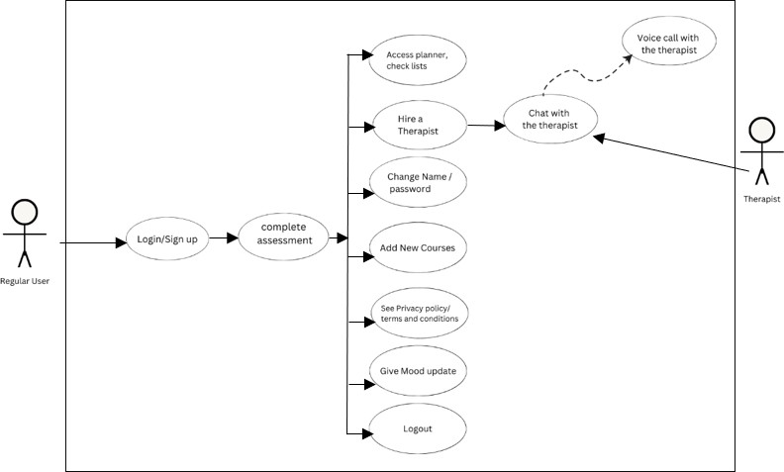

Regular User (User Scenario)
Figure 1. Use case diagram of Regular user

Identifier | User Scenario 1
Name | Accessing Personalized Mental Health Planner
Priority | High
Pre- conditions | The user has created an account on the mental health app and logged in. The user has completed the initial assessments and selected a mental health goal.

Identifier | User Scenario 1
Post- conditions | The user can access their personalized planner with daily tasks. The user has the option to consult with recommended therapists via text or call within the app.
Primary Actor | Regular User of the Mental Health App

Main Success Scenario:
  - The user logs into their account on the Gham Ghusar.
  - The user is presented with their home screen, which prominently displays their personalized mental health planner.
  - The planner includes a list of daily tasks and activities tailored to the user's selected mental health goal and assessment results.
  - The user can view and interact with the tasks, mark them as completed, and track their progress.
  - Alongside the planner, the user sees a section recommending therapists who specialize in the user's mental health goal or related disorders.
  - The user can view profiles of the recommended therapists, including their qualifications, specialties, and user reviews.
  - The user has the option to initiate text or call conversations with the therapists directly within the app for additional guidance and support.
  - The user can access their planner and therapist recommendations at any time by logging into their account on the app.

Extensions:
  - If the user has multiple mental health goals or has selected more than one disorder, the app allows the user to switch between different planners and view corresponding tasks and recommendations.
  - If the user encounters technical issues or requires assistance, the app provides a support system to contact customer service for help.
  - This user scenario represents a typical interaction of a regular user utilizing Gham Ghusar’s features to access a personalized planner, receive recommendations for therapists, and engage in ongoing mental health support.

Psychologist End (Description and Priority)

The system provides signup/login feature to therapist to provide their services for the users of the application. The therapist must register themselves to login to the system. After that they must complete their profile by uploading their documents. Then they must complete their assessment and if they pass that assessment, they will receive an interview email and a waiting request will be displayed on their account for some time. If they pass the interview they will be hired and after that they will have a chat box where they can communicate with the user who hires them and a request section where they will be able to see requests sent by users and if they don’t want to have a client they may recommend it to some other therapist on the application. The system saves the user information in database.

Stimulus/Response Sequences

- Fill in a registration form to access the system.

- If you are already registered, enter the correct username and password to login to the system.

- Complete profile and give assessment.

- Pass the assessment, then wait for the interview and final hiring.

- Manage user requests

- Chat with the customer

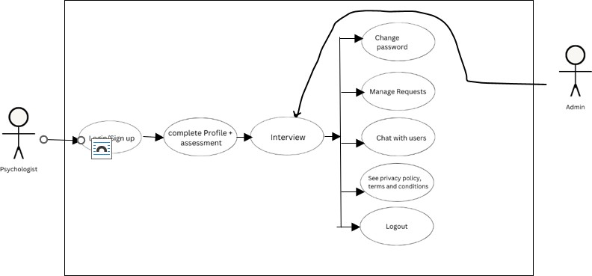
Figure 2.Use case psychologist end

Identifier | Psychologist User Scenario
Name | Psychologist Account Creation and Approval Process
Priority | High
Pre- conditions | The psychologist accesses the mental health app and begins the account creation process. The psychologist has the necessary qualifications and documentation for the application.
Post- conditions | The psychologist's application is either rejected or approved. If approved, the psychologist can log in, edit their profile information, and start communicating with users.
Primary Actor | Psychologist

Main Success Scenario:
  - The psychologist accesses the mental health app and initiates the account creation process.

  - The psychologist is directed to a test assessing their knowledge and expertise in the field of mental health.
  - If the psychologist passes the test, they are prompted to fill out a detailed form with their personal and academic information, qualifications, and any relevant documents such as degrees or certifications.
  - The psychologist submits the form and documents.
  - The psychologist's application enters a pending state for review by the admin.
  - Meanwhile, the admin panel receives a notification about the pending application and can access the psychologist's submitted documents.
  - The admin reviews the documents and either rejects the application or proceeds to send an interview email to the psychologist.
  - If the application is rejected, the psychologist is notified of the rejection.
  - If an interview is scheduled, the admin sends an email to the psychologist containing the interview details and a link to the interview platform.
  - The psychologist participates in the interview.
  - Based on the interview performance, the admin can either approve or reject the psychologist's application.
  - If approved, the psychologist receives an approval email and can log into their account on the mental health app.
  - The psychologist can then edit their profile information, such as contact details or profile picture, and set their availability for consultations.
  - The psychologist can communicate with users through the app's chat system and provide mental health support.

Extensions:
  - If the psychologist's application is rejected, the psychologist has the option to reapply after addressing the issues highlighted by the admin.
  - Psychologists can update their profile information or qualifications at any time after approval by accessing the profile editing feature in the app.

Admin panel (user scenario)

Identifier | Admin User Scenario
Name | Admin Management of Psychologist Applications and User Records
Priority | High
Pre- conditions | The admin accesses the admin panel or separate admin APK for the mental health app. Psychologist applications and user records are accessible to the admin.
Post- conditions | The admin can review psychologist applications, conduct interviews, approve psychologists, manage user records, and generate reports as needed.
Primary Actor | Admin

Main Success Scenario:
  - The admin logs into the admin panel or separate admin APK.
  - The admin is presented with a dashboard displaying psychologist applications and user records.
  - The admin can view pending psychologist applications and access the submitted documents for each application.
  - The admin can review the documents and make a decision to either reject the application or proceed with an interview.
  - If an interview is scheduled, the admin sends an interview email to the respective psychologist, containing interview details and a link to the interview platform.
  - The admin conducts the interview.
  - Based on the interview performance, the admin can approve or reject the psychologist's application.
  - If approved, the admin sends an approval email to the psychologist.
  - The admin can manage and update user records, including therapist applications, as necessary.
  - The admin has access to reports generated by the system, providing insights

Extensions
  - User Management: The admin panel can include features to manage user accounts, such as user registration, account verification, password resets, and user data privacy settings.
  - Therapist Management: In addition to handling psychologist applications, the admin panel can allow admins to manage the profiles and details of approved therapists, including updating their information, verifying their credentials periodically, and reviewing user feedback and ratings.
  - Appointment Scheduling: The admin panel can incorporate a scheduling system for therapists and users, enabling admins to manage and oversee appointments, track availability, and handle rescheduling or cancellations.
  - Content Management: The admin panel can include tools for managing content within the app, such as creating and editing articles, blog posts, or resources related to mental health. Admins can review and approve content submitted by therapists or other contributors.
  - Analytics and Reporting: The admin panel can provide comprehensive analytics and reporting features to track app usage, user engagement, therapist performance, and other relevant metrics. This data can help identify trends, assess the effectiveness of the platform, and make informed decisions for improvements.
  - Notifications and Communication: The admin panel can include a notification system that allows admins to send important announcements or updates to users and therapists. It can also facilitate communication with users, therapists, and support staff via internal messaging or chat functionalities.
  - Data Security and Compliance: The admin panel should have robust security measures in place to protect user and therapist data. It should comply with relevant privacy

regulations and enable admins to manage data access, conduct audits, and implement security protocols.
  - Financial Management: If the app involves financial transactions, the admin panel can include features to manage payment processing, subscription plans, billing, and financial reporting.

Other Nonfunctional Requirements

Performance Requirements
- The mobile application will take initial load time depending on internet connection strength.
- The performance of the application will depend upon memory space.
- The mobile application will support the use of multiple users at a time.
- The web application shall accommodate high number of Services, customers, and sellers without any fault.
- Responses to view information shall take no longer than 10 seconds to appear on the screen.

Safety Requirements
A psychologist will need to sign an agreement before the hiring.

Security Requirements
- System shall provide data Security
- System shall prevent Privacy leakage.
- System shall not sell any personal information of users.
- System shall provide two Factor Authentication to users for verification of accounts.

Software Quality Attributes
- Integrity:
The system will be secure enough that no personal information will be changed or modified by any other person.

Maintainability:
The software will be composed of various modules decreasing the complexity of expansion.

Portability:
As stated previously, this mobile application will only run on android phones. And layout of the application will also adjust according to screen size.

Reliability:

The application will be thoroughly tested, and any issues resolved. The data entered must be correctly stored in the database. In addition, the database should use transactions so that partial entries will not be stored in the database.

Supportability:
The application will be designed in such way that it works even on systems having the minimum configuration. The system will be adaptable even if additional plugins or modules are added at a later point.

Implementation:
The System User Interface is built using Microsoft Visual Studio 2019. The Database is implemented using Firebase, SQL server and SQLite local database.

Availability:
This application will be available all the time for users to see and access their planners anytime, the notification will show to the user if he is about to miss a certain task.

Usability:
The application will be used by young and adults. The system shall be intuitive to use and have extensive online help documentation to walk users through the operations they are trying to perform. The application will satisfy the maximum number of customer needs.

Other Requirements

In addition to the core functionalities outlined in the previous sections, the mental health app should fulfill certain additional specifications. The app's user interface should be designed with an intuitive and user-friendly approach, ensuring clear navigation and incorporating accessibility features to cater to individuals with disabilities. should go through alpha and beta both testing before making it available to all users so that it comes in market with least chances of error.

Software Lifecycle Models

The Project Lifecycle is a methodology. The reason for a project to follow just one Methodology when undertaking a project is simple. This allows to have a set of standards to follow along with an organized path for the team to know what direction to go.

Chosen methodology:

We choose the waterfall Software Development Model for our project as the FYP plan of the organization was already in the waterfall flow.

Waterfall Methodology:

In the Waterfall model, the development process follows a linear and sequential approach, where each phase is completed before moving on to the next. Requirements are gathered and analyzed at the beginning, followed by system design, implementation, and maintenance.
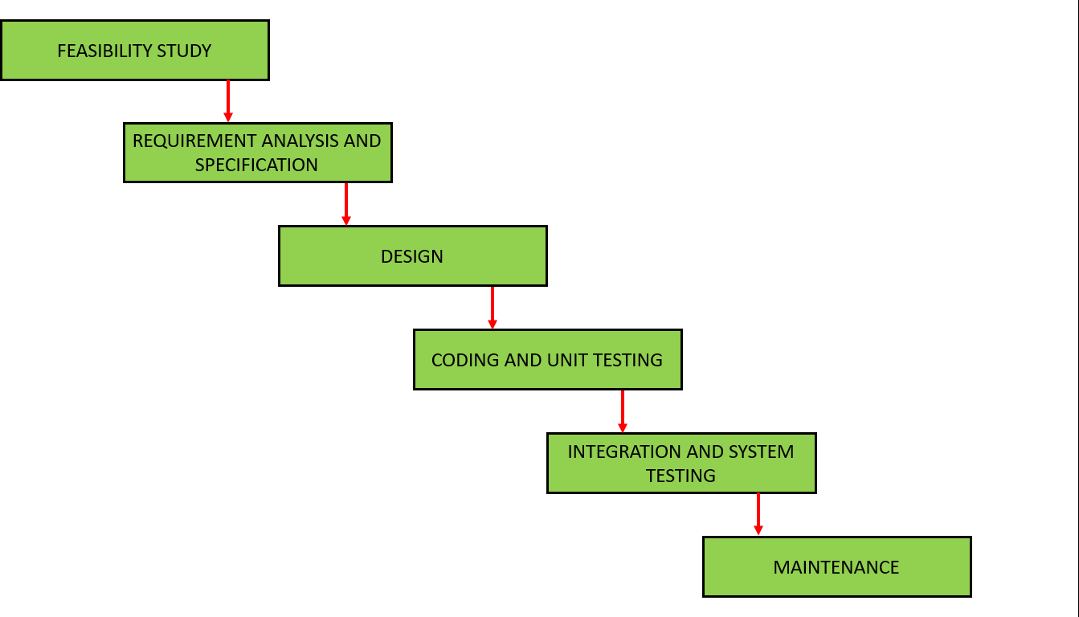
Figure 3. Waterfall model visual representation

Step 1: Requirements gathering and analysis
In this phase, you gather detailed requirements for your mental health app by conducting interviews and discussions with users. Identify their expectations and needs for the app, including features, functionality, and goals.

Step 2: System design
Based on the requirements gathered, create a comprehensive design for your mental health app. This includes designing the user interface, defining the system architecture, and determining the overall structure of the app.

Step 3: Implementation
With the design in place, start developing the mental health app. This phase involves writing the code, integrating different components, and implementing the planned features based on the design specifications.

Step 4: Testing
Once the implementation is complete, thoroughly test the app to ensure it functions correctly. Perform various types of testing, including functional testing, usability testing, and performance testing, to identify and address any bugs or issues.

Step 5: Deployment
After successful testing, deploy the app to a production environment. This involves making the app available for users to download and use. Prepare necessary documentation, configure servers or hosting platforms, and ensure the app is ready for public release.

Step 6: Maintenance
Once the app is deployed, ongoing maintenance is required to keep it running smoothly. Monitor the app for any issues, address user feedback, and release updates or bug fixes as necessary. Regularly update the app to enhance its functionality and address any security vulnerabilities.
In the Waterfall model, each phase is completed before moving on to the next, and there is minimal overlap between phases. This approach provides a structured framework for the development of your mental health app, ensuring that each stage is thoroughly completed and reviewed before progressing to the next.

Reason to choose this Methodology:
The Waterfall model is a well-established and traditional approach to software development that offers several advantages in certain situations. Here are some reasons why I have chosen the Waterfall model:
- Clarity and Predictability: The Waterfall model follows a linear and sequential flow, where each phase is completed before moving on to the next. This provides a clear structure and allows for better predictability in terms of project timelines, milestones, and deliverables.
- Comprehensive Planning: The Waterfall model emphasizes upfront planning and requirements gathering. This ensures that project requirements are clearly defined and documented before moving into the development phase. A comprehensive plan helps manage expectations, budget, and resources.
- Stable Requirements: If the project has stable and well-understood requirements that are unlikely to change significantly during development, the Waterfall model can be a suitable choice. It works best when requirements can be clearly defined early on and changes are minimal.
- Documentation and Traceability: The Waterfall model places importance on documentation at each phase, resulting in well-documented requirements, design specifications, and test cases. This documentation enables better traceability and can be beneficial for future reference or when dealing with compliance requirements.
- Client Involvement: The Waterfall model often involves client or stakeholder sign-off at each phase, allowing for more formal review and approval processes. This involvement ensures that the project remains aligned with client expectations and reduces the risk of miscommunication or misunderstandings.
- Risk Mitigation: The Waterfall model's sequential nature enables early identification and mitigation of risks. By conducting comprehensive planning and analysis upfront, potential risks can be identified and addressed before proceeding to subsequent phases.

Work plan:

Phases Description of Work Start and End Dates

Table 5. work plan of GHAMGHUSAR

Phases | Work |  | Dates
Phase1 | Proposal submission | 2nd week of October,2022
Phase2 | SRS(Software Requirement Specification)) | 2nd week of November, 2022
Phase3 | Interface Design demo | 1st week of January, 2023
Phase4 | SDD(Software design document) Submission | 2nd week of January, 2023
Phase5 | Re-Design | 3rd week of February, 2023
Phase6 | Database creation | Last week of February, 2023
Phase7 | Coding / Backend Implementation | March & April, 2023
Phase8 | Documentation | 3rd week of May, 2023
Phase9 | Internal representation |  | 24th of May, 2023

Project structure

This Project went through different phases like planning, requirement gathering, documentation of functional and nonfunctional requirements, analyzing, designing, prototyping, database designing, actual development and testing and then final documentation.

Team Structure

Table 6. Team Structure

Structure of development team
Fatima | Planning, Requirement gathering, Designing, Database modelling, backend, Testing, Versioning, Documentation, Technical Report Writing

Project Schedule:
Table 7. Gantt Chart first 4 months of the development process

 | October |  |  |  | November |  |  |  | December |  |  |  | January
 | 1w | 2w | 3w | 4w | 1w | 2w | 3w | 4w | 1w | 2w | 3w | 4w | 1w | 2w | 3w | 4w
Registeration
proposal
prepration
proposal
presentation
proposal
revision
designing /SRS

Table 8. Gantt chart of last 4 months of the development process
Febraury
March
April
May
1w 2w 3w 4w 1w 2w 3w 4w 1w 2w 3w 4w 1w 2w 3w 4w
backened
database
Re-Design
InterfaceDemo
designing /SDD

CHAPTER 3
Designing the Project

© Project Management Office Revised Version 5.0
Department of Computer Science, GC Women University Sialkot.
22

3 Designing the project

  - Architecture Design Diagram:
We Have Build our project in C# Xamarin MVVM(Model View ViewModel) Architecture. It allows us to build project using Object Oriented Approach. We Create Models (classes) that are mapped on our database design and used to communicate with database through indirect approach, which adds extra security to our data. Figure 4 Illustrates how MVC architecture works.
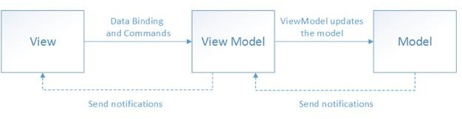

Sequence Diagrams
Figure 4. Architecture Design Diagram

The sequence diagram is so useful is because it shows the interaction logic between the objects in the system in the time order that the interactions take place. It shows how objects operate with one another and in what order in this Ghamghusar Mobile Application.

Signup for Regular user

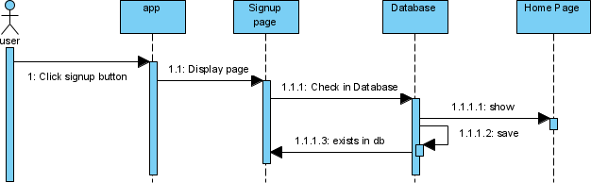

Figure 5. Sequence diagram for regular user signup

Login for Regular-users//psychologists

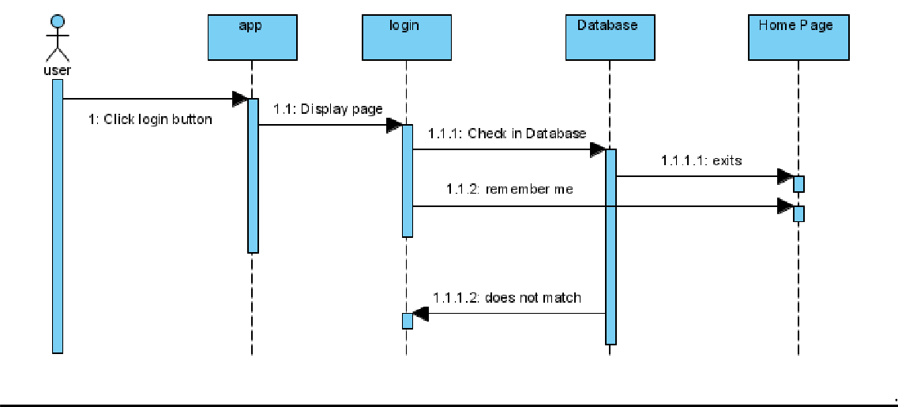

Figure 6. Sequence diagram login

Assessments

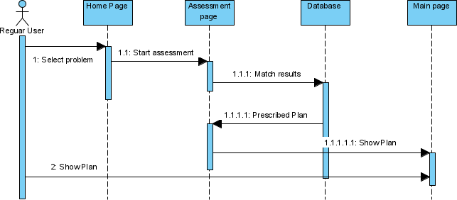

Figure 7- Sequence diagram user assessments

Daily Task/Activities

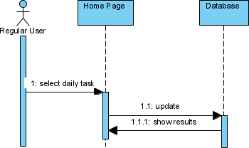

    - Additional courses:
Figure 8 -Sequence diagram daily planner

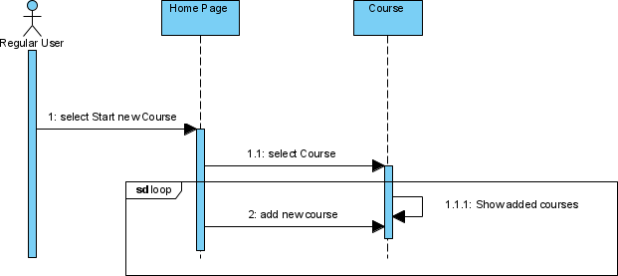

Figure 9- Sequence diagram additional courses

Program switching:
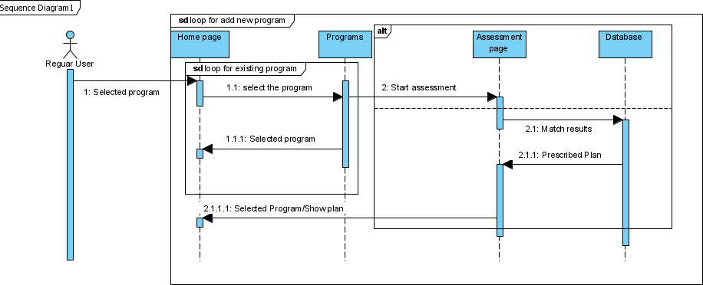

Figure 10 - Sequence diagram switching programs

Chatting with therapist

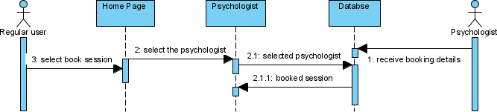

Figure 11 -Sequence diagram chatting with the therapist.

Chat by therapist

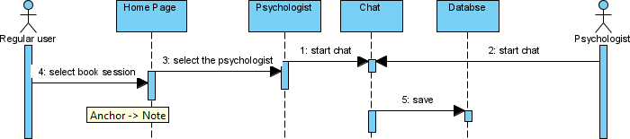

Figure 12 -Sequence diagram chatting by the therapist.

Logout

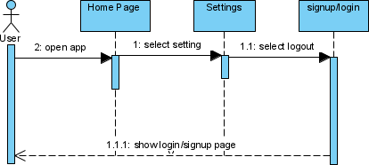

Figure 13 -Sequence diagram logout.

Psychologists’ Assessment
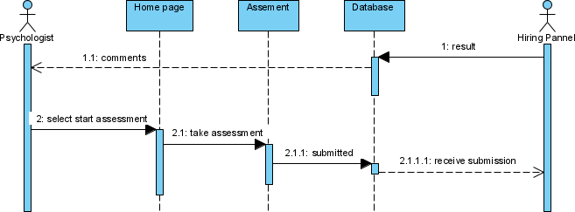

Figure 14 -Sequence diagram Psychologists’ assessment.

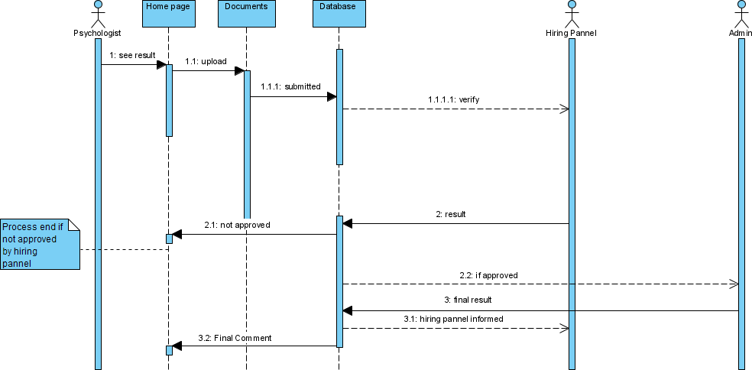
Document approval and interview appointment

Figure 15 -Sequence diagram document approval and interview appointment.

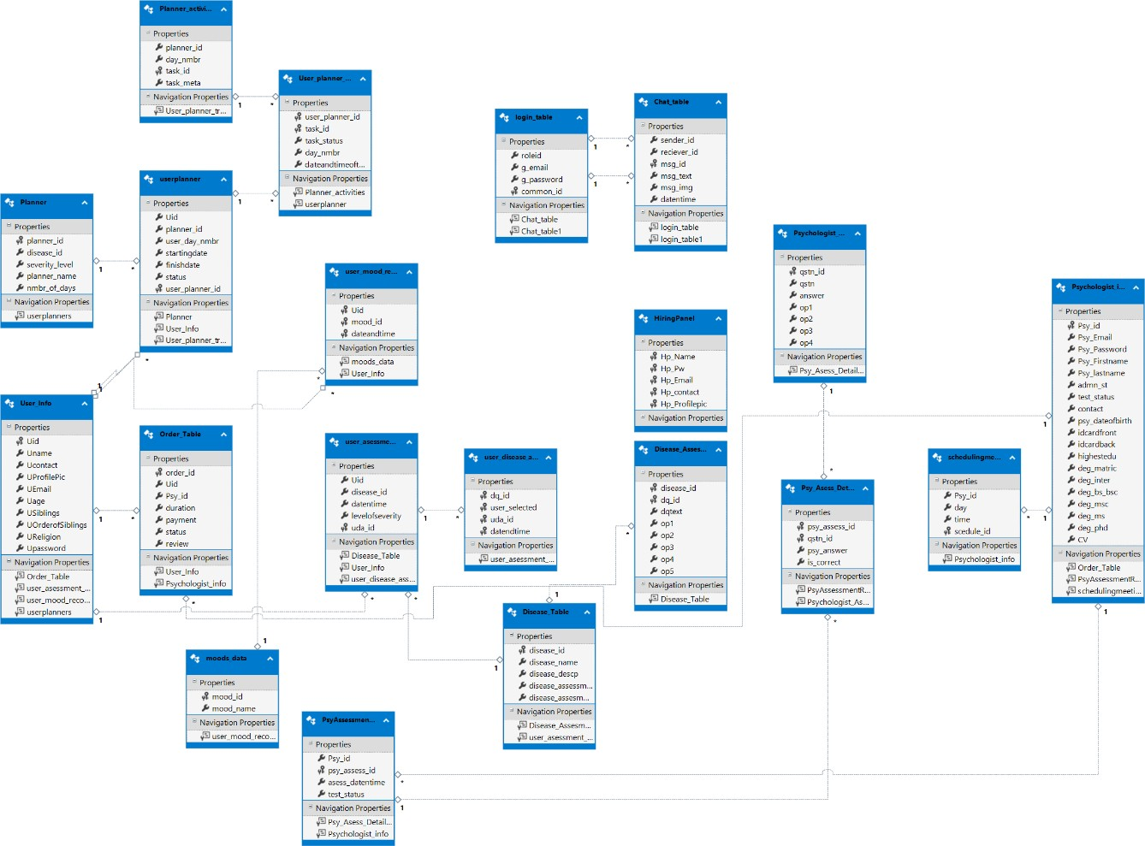
Class Diagram

Figure 16 -. Class Diagram of Complete Project

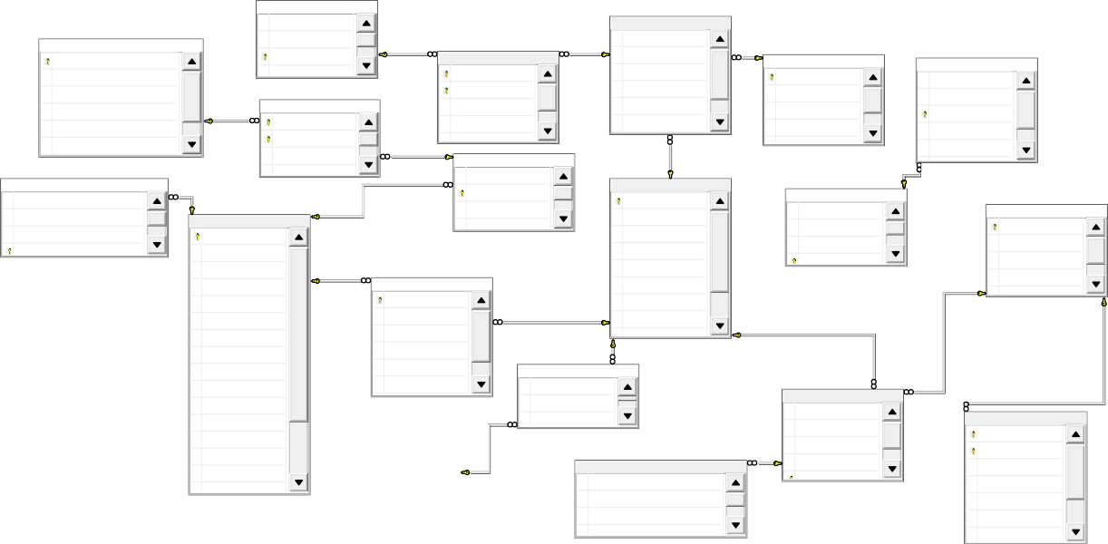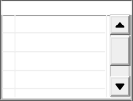Database Diagram:
userplanner
Uid
User_planner_tracking
user_planner_id task_id
task_status day_nmbr
dateandtimeofthetask
planner_id

user_day_nmbr startingdate finishdate
status
User_Info
Uid
Psychologist_info
Psy_id

Psy_Email

Psy_Password Psy_Firstname Psy_lastname admn_st
test_status contact
psy_dateofbirth idcardfront
idcardback highestedu deg_matric deg_inter
[deg_bs/bsc]

deg_msc
Uname Ucontact UProfilePic UEmail Uage USiblings
UOrderofSiblings
user_asessment_result
Uid
disease_id datentime
user_disease_assesment_detail_check
dq_id

user_selected uda_id
datendtime
levelofseverity
Disease_Assesment_Table
disease_id dq_id
dqtext op1 op2 op3
op4
dateandtime
mood_id
Uid
user_mood_record
Hp_contact
Hp_Email
Hp_Pw
Hp_Name
HiringPanel
status
payment
duration
Psy_id
Uid
order_id
Order_Table
disease_assessment_n...
disease_descp
disease_name
disease_id
Disease_Table
common_id
g_password
g_email
roleid
login_table
scedule_id
time
day
Psy_id
schedulingmeetingpsychologistend
test_status
asess_datentime
psy_assess_id
Psy_id
PsyAssessmentResult
is_correct
psy_answer
qstn_id
psy_assess_id
Psy_Asess_DetailCheck
msg_img
msg_text
msg_id
reciever_id
sender_id
Chat_table
planner_name
severity_level
disease_id
planner_id
Planner
op3
op2
op1
answer
qstn
qstn_id
Psychologist_Asessment_Questions
task_meta
task_id
day_nmbr
planner_id
Planner_activities

moods_data
mood_id
mood_name

Figure 17-Database design

Design of Ghamghusar

Reasons why I am using a pastel palette in my UI.

- Individuals having High scores of anxiety are less likely towards more saturated colors and prefer pastel shades. [4]
- There exists a certain correlation between colors and emotions and it vary with age groups. [5]
- light colors like sky blur, light green pink and white are strongly inked with positive emotions like happiness and calmness. [6]

3.5.1. Psychologist End
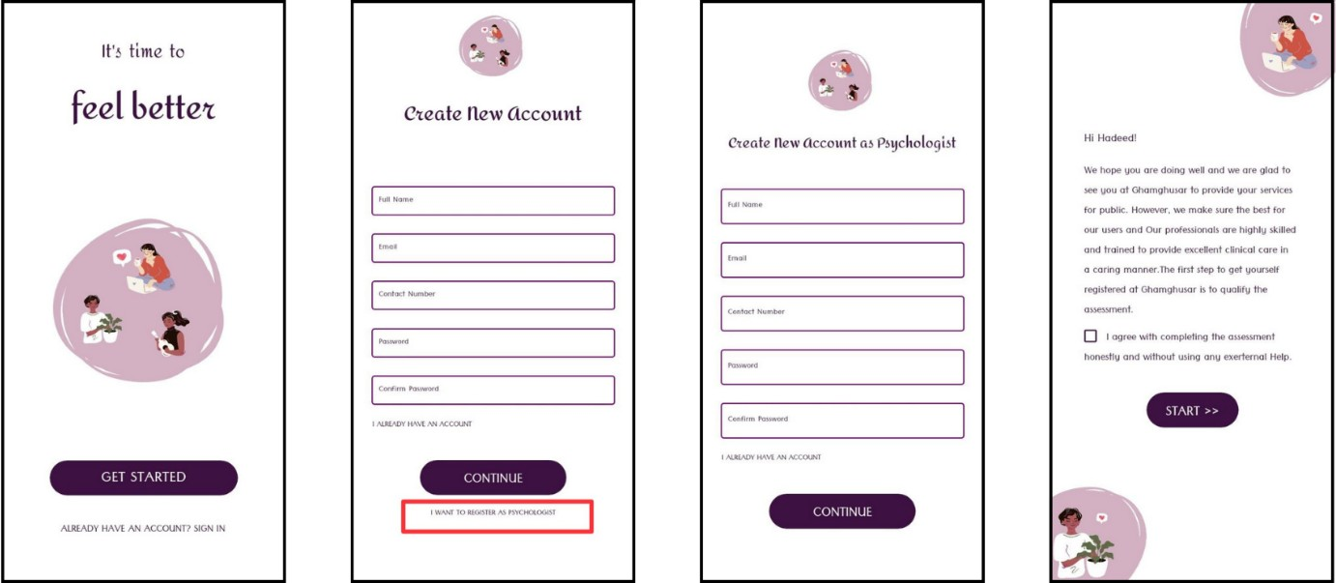
Figure 18- Psy end Figure 19- Psy. signup Figure 20- Psy BA
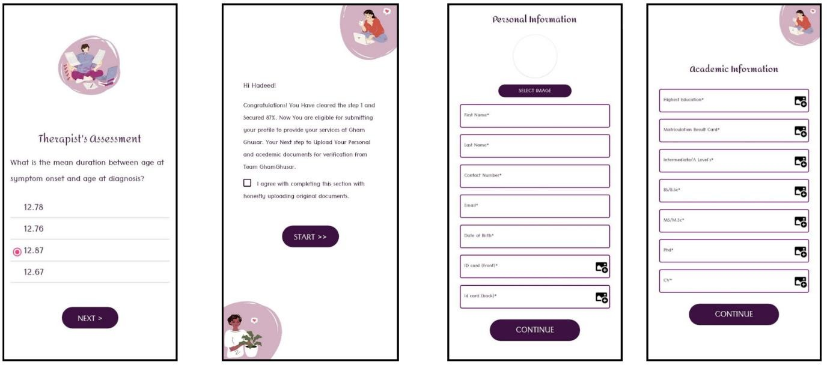
Figure 21- Psy test Figure 22- test result Figure 23- Psy. Personal and acedemic Info

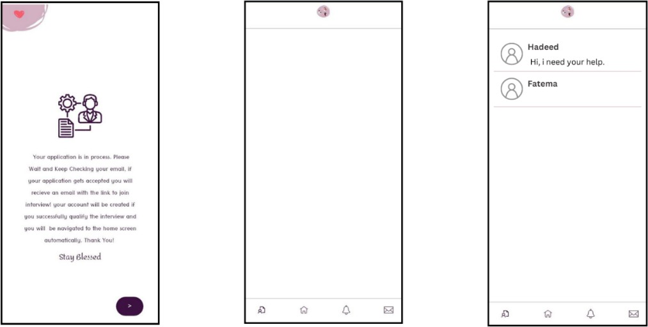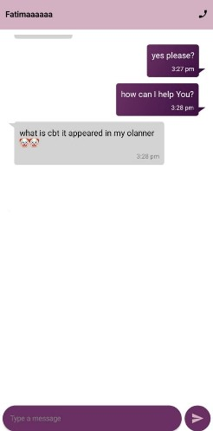

Figure 24- waiting page Figure 25- Psy home. Figure 26- Psy chat Figure 27.- chat

Regular user end
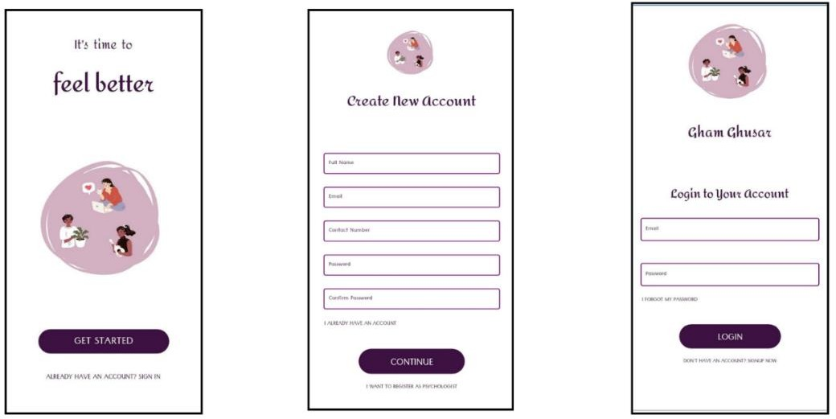

Figure 28- Main page Figure 29- signup Figure 30- Login

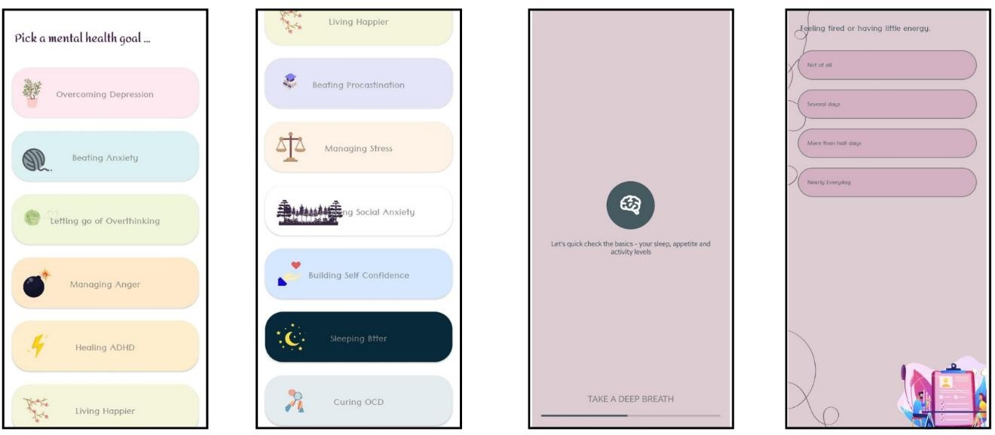

Figure 31- Pick a mental health goal Figure 32- load assess Figure 33- disorder aseessment

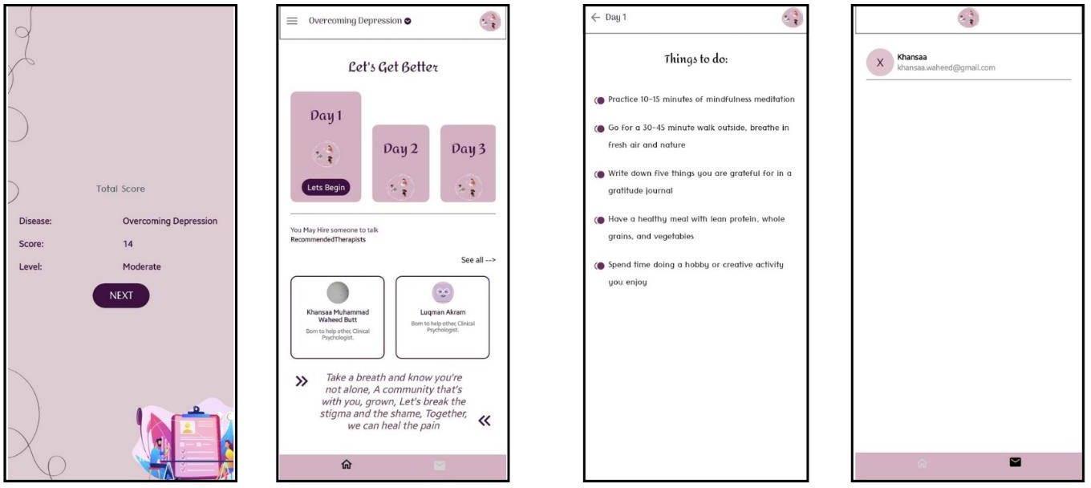

Figure 34- results Figure 35- Home Figure 36- Planner Figure 37- chatbox

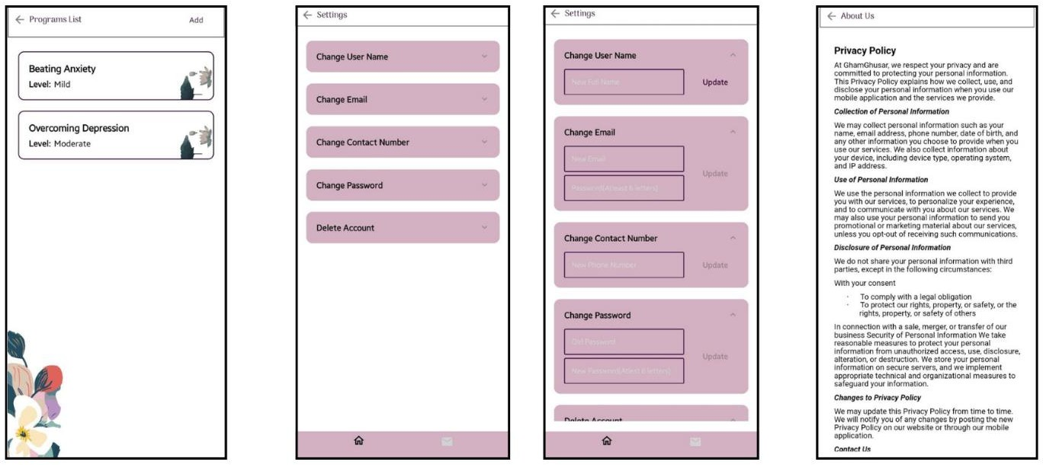

Figure 38- Switch course Figure 39- edit profile info Figure 40- Policy

Admin End

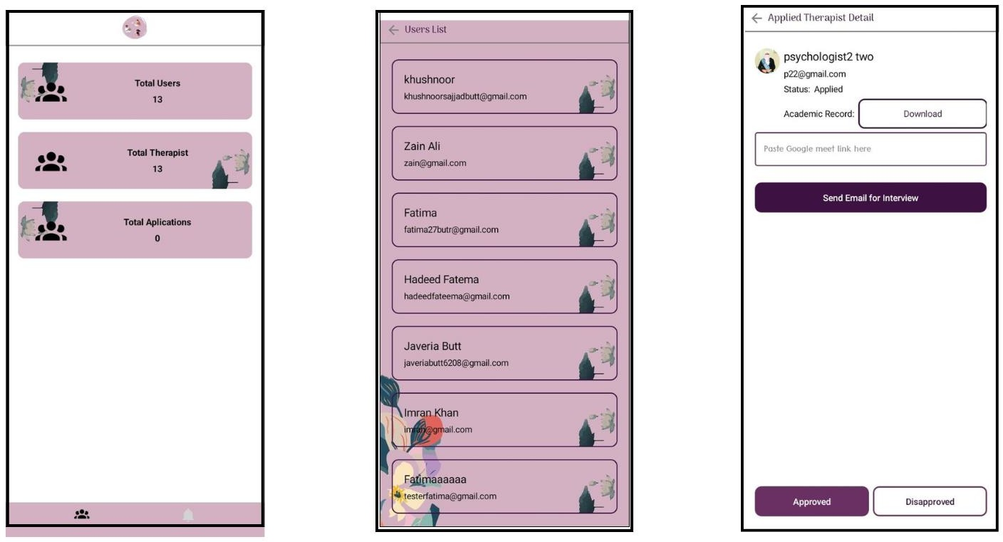

Figure 41- Admin home Figure 42- Pending Applications Figure 42- App. Detail

CHAPTER 4
Development

© Project Management Office Revised Version 5.0
Department of Computer Science, GC Women University Sialkot.
33

4 Development:

Development Plan architecture
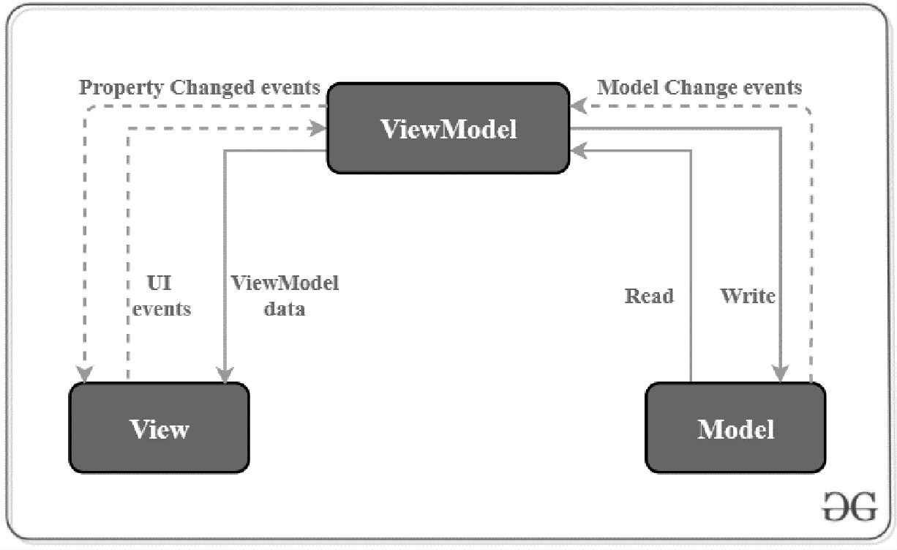

Figure 44. Development plan

The MVVM pattern is commonly used in C# and Xamarin app development, for the following reasons:
    - Separation of Concerns: MVVM helps separate the user interface (View) from the business logic (ViewModel) and data (Model). This separation improves code organization, maintainability, and testability.
    - Enhanced Testability: With MVVM, you can easily test the ViewModel independently of the View. This promotes unit testing and makes it simpler to validate the app's behavior and logic.
    - Data Binding: MVVM leverages powerful data binding mechanisms provided by Xamarin, allowing seamless synchronization of data between the View and ViewModel. This simplifies UI updates and reduces the need for manual data manipulation.
    - Flexibility and Adaptability: MVVM supports adaptability to changing UI requirements. It enables easy modification of the View while keeping the ViewModel and Model intact, facilitating UI updates and changes without impacting the underlying logic.
    - Developer Collaboration: MVVM enhances collaboration between developers by providing clear separation of responsibilities. Developers can work simultaneously on the View and ViewModel without conflicting with each other's code.
© Project Management Office Revised Version 5.0

    - Platform-Agnostic: Xamarin allows code sharing between multiple platforms, such as iOS and Android, and MVVM aligns well with this cross-platform development approach. The ViewModel and Model can be shared across platforms, while platform- specific Views can be created separately.
By adopting the MVVM pattern in our mental well-being app developed in C# and Xamarin, i achieved better code organization, testability, flexibility, and collaboration, ultimately resulting in an efficient and maintainable application.

Test Cases:

- Register

Test Engineer | Fatima
Test Case ID | TC-1
Related UC/FR/NFR
Actor | End User
Date
Purpose | To get registered as a user
Pre-Req
Test Data | Personal Information
Steps | - Open Application  - Click on ‘Register as a user’  - Enter Name, Email, Contact, Password  - Select Religion  - Upload Profile Picture  - Select Number of Siblings and Order in Siblings  - Check ‘Accept Terms and Conditions’  - Click ‘Sign Up’
Status

Register as a Psychologist

Test Engineer | Fatima
Test Case ID | TC-2
Related UC/FR/NFR
Actor | Psychologist
Date
Purpose | To get registered as a psychologist
Pre-Req | Having the application installed
Test Data | Personal Information
Steps | - Open Application  - Click on ‘Register as a Psychologist’  - Enter First Name, Last Name, Email, Contact, Password  - Check ‘Accept Terms and Conditions’  - Click ‘Sign Up’
Status

- Login
© Project Management Office Revised Version 5.0

Test Engineer | Fatima
Test Case ID | TC-3
Related UC/FR/NFR
Actor | End User / Psychologist / Hiring Personnel / Admin
Date
Purpose | To login the application
Pre-Req | Get registered
Test Data | Email, Password
Steps | - Open Application  - Enter Email  - Enter Password  - Click ‘Login’
Status

Edit Profile

Test Engineer | Fatima
Test Case ID | TC-4
Related UC/FR/NFR
Actor | End User / Psychologist / Hiring Personnel / Admin
Date
Purpose | To let a user, edit their profile
Pre-Req | Registered as a user
Test Data | Updated information
Steps | - Open Application  - Open side Menu  - Click on ‘Profile’  - Click on ‘Edit’  - Change the field you want changed  - Click ‘Save’
Status

- See Privacy Policy / Terms and Conditions

Test Engineer | Fatima
Test Case ID | TC-5
Related UC/FR/NFR
Actor | End User / Psychologist / Hiring Personnel
Date
Purpose | To let a user read the terms and conditions for using the application
Pre-Req | Registered as a user
Test Data
Steps | - Open Application  - Open side Menu  - Click on ‘Terms and Conditions’  - Read Terms and Conditions
Status

Take assessment

Test Engineer | Fatima
Test Case ID | TC-6
Related UC/FR/NFR
Actor | End User
Date
Purpose | To let a user, take a disease assessment
Pre-Req | Registered as a user
Test Data | User’s Choices
Steps | - Open Application  - All goals/disease will be displayed, select a goal or a disease  - Click on ‘Start the assessment’  - Click on ‘Next’  - Choose one option against every question (Assessment will be divided into three parts)  - Read your assessment results and click on ‘Prepare my plan’  - Click ‘Check it out’ once your plan is made and you will be redirected to the home page of the app
Status
Status

- Access daily tasks

Test Engineer | Fatima
Test Case ID | TC-8
Related UC/FR/NFR
Actor | End User
Date
Purpose | To access daily tasks of planner
Pre-Req | Assessment for a disease taken
Test Data
Steps | - Open Application  - Current planner weekdays will be displayed on Home Page, select your day  - Click on task to carry out its activity
Status

Start new additional course

Test Engineer | Fatima
Test Case ID | TC-9
Related UC/FR/NFR
Actor | End User
Date
Purpose | To add new additional course
Pre-Req | Picked a goal/disease
Test Data
Steps | - Open Application  - Scroll down on Home Page

3. From the various options, select an additional course and carry out day 1 activity
Status

- Access additional courses

Test Engineer | Fatima
Test Case ID | TC-10
Related UC/FR/NFR
Actor | End User
Date
Purpose
Pre-Req | Picked a goal/disease
Test Data | User’s Choices
Steps | - Open Application  - Scroll down on Home Page  - From the various options, either continue a previously added course a start a new one
Status

Add new program

Test Engineer | Fatima
Test Case ID | TC-11
Related UC/FR/NFR
Actor | End User
Date
Purpose | Add a new program (goal/disease)
Pre-Req | Already picked a goal/disease
Test Data | User’s Choices
Steps | - Open Application  - On home page, click on the drop down showing at the top of the screen with your current program’s name  - Click on ‘Add program’  - All goals/disease will be displayed, select a goal or a disease  - Click on ‘Start the assessment’  - Click on ‘Next’  - Choose one option against every question (Assessment will be divided into three parts)  - Read your assessment results and click on ‘Prepare my plan’  - Click ‘Check it out’ once your plan is made and you will be redirected to the home page of the app
Status

- Switch between programs

Test Engineer | Fatima
Test Case ID

Related UC/FR/NFR
Actor | End User
Date
Purpose | Switch between goal/disease programs
Pre-Req | Picked two or more goals/diseases
Test Data
Steps | - Open Application  - On home page, click on the drop down showing at the top of the screen with your current program’s name  - Select the program you want to switch to
Status

Hire a therapist

Test Engineer | Fatima
Test Case ID | TC-13
Related UC/FR/NFR
Actor | End User
Date
Purpose | To hire a therapist (book a session)
Pre-Req | Registered as a user
Test Data
Steps | - Open Application  - Go to ‘Profile’  - Click on ‘Book Session’  - View different psychologist's profiles and select the one you prefer  - Select from their available days and time slots  - Select a payment method  - Click ‘Book a session with this psychologist’  - After payment is verified, your session will be booked
Status

- Chat with a therapist

Test Engineer | Fatima
Test Case ID | TC-14
Related UC/FR/NFR
Actor | End User
Date
Purpose
Pre-Req
Test Data
Steps
Status

Submit a report

Test Engineer | Fatima
Test Case ID | TC-15

Related UC/FR/NFR
Actor | End User
Date
Purpose | To submit a report regarding a session
Pre-Req | Have had a session with a psychologist
Test Data | Psychologist Name, Report Message, Rating
Steps | - Open Application  - Open side Menu  - Click on ‘Submit a report’  - A form will be displayed, select the psychologist from the drop-down menu  - Enter your detailed message  - Choose rating  - Click ‘Submit’
Status

- Give Test

Test Engineer | Fatima
Test Case ID | TC-16
Related UC/FR/NFR
Actor | Psychologist
Date
Purpose | To give test assessment as a psychologist
Pre-Req | Registered as a psychologist
Test Data | Psychologist’s Choices
Steps | - Open Application  - From home page, select ‘Start Test Assessment’  - Choose one option from every question that is asked  - When done, click on ‘Submit Assessment’
Status

Join an interview

Test Engineer | Fatima
Test Case ID | TC-17
Related UC/FR/NFR
Actor | Psychologist
Date
Purpose | To join a hiring interview
Pre-Req | Profile approved for interview
Test Data
Steps | - Open Application  - Scroll down to ‘Interview’  - Click ‘Join Now’
Status

- Complete profile

Test Engineer | Fatima

Test Case ID | TC-18
Related UC/FR/NFR
Actor | Psychologist
Date
Purpose | To complete profile after approval from admin
Pre-Req | Approval from Admin
Test Data | Psychologist’s Personal and Academic Information
Steps | - Go to Profile from side menu  - Click ‘Edit’  - Enter Personal Details  - Enter Academic Details  - Click ‘Complete’
Status

Manage user requests

Test Engineer | Fatima
Test Case ID | TC-19
Related UC/FR/NFR
Actor | Psychologist
Date
Purpose
Pre-Req
Test Data
Steps
Status

- Chat with users

Test Engineer | Fatima
Test Case ID | TC-20
Related UC/FR/NFR
Actor | Psychologist
Date
Purpose
Pre-Req
Test Data
Steps
Status

Approve/Disapprove psychologist’s profiles

Test Engineer | Fatima
Test Case ID | TC-23
Related UC/FR/NFR
Actor | Hiring Personnel
Date
Purpose | To approve/disapprove psychologist profile for interview

Pre-Req
Test Data | Psychologist’s Profile
Steps | - Open Application  - Click Psychologist Profiles  - Select a profile and go through it  - Click ‘Approve’ or ‘Disapprove’
Status

- Approve psychologists

Test Engineer | Fatima
Test Case ID
Related UC/FR/NFR
Actor | Admin
Date
Purpose
Pre-Req
Test Data
Steps
Status

Manage Reports

Test Engineer | Fatima
Test Case ID | TC-26
Related UC/FR/NFR
Actor | Admin
Date
Purpose | Manage reports submitted by users
Pre-Req
Test Data
Steps
Status

CHAPTER 5
Conclusion and Future Work

© Project Management Office Revised Version 5.0
Department of Computer Science, GC Women University Sialkot.
43

5 Conclusion and Future Work:

Conclusion:

In conclusion, Gham Ghusar is a transformative Android application designed to revolutionize mental health care. With its user-friendly interface and comprehensive features, it offers a wide range of resources and support to enhance mental well-being. By leveraging cognitive AI, the app goes beyond traditional solutions, addressing 12 common mental health problems and providing personalized treatment courses. Gham Ghusar also facilitates seamless communication with licensed psychologists, creating a supportive environment. Its goal is to empower individuals, improve mental health outcomes, and promote a happier life.

Achievements:

    - Beautiful and User-friendly Mental wellbeing app.
    - Planner generation.
    - One Platform for all mental health resources
    - Chat Feature
    - Psychologist end

Future work:

- Integration of Audio Therapies: Incorporate audio therapy sessions within Gham Ghusar to provide users with an additional modality for mental health support.
- Expansion of Exclusive Paid Content: Offer a premium subscription plan that grants users access to exclusive content, such as advanced therapy sessions, specialized courses, and expert-led workshops.
- Continuous Content Updates: Regularly update and expand the app's content library with new exercises, activities, and resources to keep users engaged and provide ongoing support.
- Enhanced Community Features: Strengthen the app's community aspect by introducing discussion forums, support groups, and peer-to-peer interaction, fostering a sense of connection and shared experiences.
- Partner with Mental Health Professionals: Collaborate with a network of mental health professionals to offer virtual consultations, expert Q&A sessions, and personalized guidance through the app.
- Integration with EHR Systems: Explore integration with electronic health record (EHR) systems to ensure seamless sharing of information between Gham Ghusar and healthcare providers, facilitating coordinated care.
- Mood Tracking and Progress Monitoring: Implement a feature that allows users to track their moods, set goals, and monitor their progress over time, enabling a more comprehensive understanding of their mental health journey.

- Targeted Marketing and Outreach: Develop targeted marketing strategies to reach specific demographics, raising awareness about the app's benefits and expanding its user base.
- Research and Validation: Conduct research studies and gather user feedback to validate the effectiveness and impact of Gham Ghusar, further refining its features and optimizing its outcomes.
- Localization and International Expansion: Localize the app for different languages and cultures, expanding its availability to a wider global audience and ensuring cultural sensitivity in content delivery.

REFERENCES

- Coyne, S.M., Hurst, J.L. , Dyer, W.J. et al. Suicide Risk in Emerging Adulthood: Associations with Screen Time over 10 years. J Youth Adolescence 50, 2324–2338 (2021). https://doi.org/10.1007/s10964-020-01389-6

- Ireland, Susan R., Yvonne M. Warren, and Lawrence G. Herringer. "Anxiety and color saturation preference." Perceptual and motor skills 75, no. 2 (1992): 545-546.

- Kaya, Naz, and Helen H. Epps. "Relationship between color and emotion: A study of college students." College student journal 38, no. 3 (2004): 396-405.

- Achint Kaur, 2020, A Link Between Colors and Emotions; A Study of Undergraduate Females, INTERNATIONAL JOURNAL OF ENGINEERING RESEARCH & TECHNOLOGY (IJERT) Volume 09, Issue 09 (September 2020),

APPENDIX

Appendix A: Glossary

1. Fiverr: Fiverr is a platform for Digital Skills where Users create their profile, display their skills and set rates for it and buyers can come and take their services by hiring them within the platform. For more details have a look at https://fiverr.com

